Style File
Spring/Summer 2010
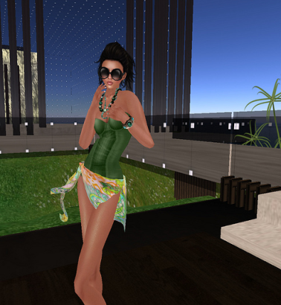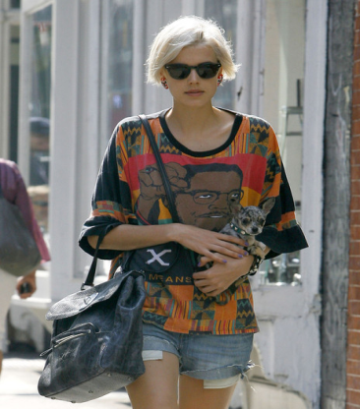
Summer in the city is upon us. And, unless you’re a multi-millionaire you won’t be spending the summer at some fancy Hawaiian resort or sailing the seas on a luxury yacht-chances are you will most likely be spending the bulk of the summer pounding the pavement of our concrete jungle “where dreams are made of.” So I’ve tailored this issue of style file to fit your budget and lifestyle no matter what that may be. And, I have also illustrated how to take it from the Runway to “Real” way!
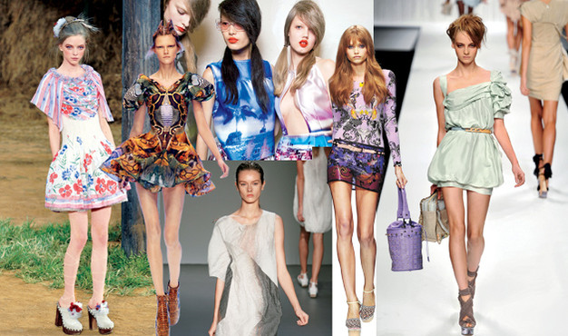
First, let’s start with some of the trends for summer 2010… many of which you’ve probably seen on the streets at this point. Look for sporty chic, military utilitarian clothes, denim on denim, floral prints on dresses, rompers and tops. Designers also showed a plethora of prints and let’s not forget nautical stripes. And while most of these trends can be worn anywhere by almost any chic female-I like to divide them up into locales and places we will be spending most of the summer they are: The Country, The City and The Beach!
Town & Country
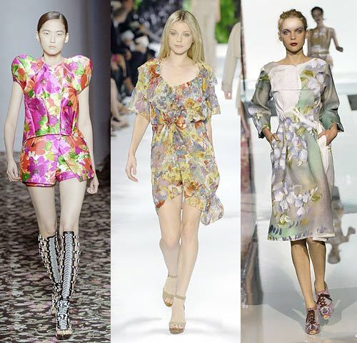Runway to ‘real’ way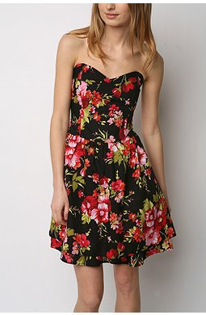
Flower Power!
First…for the Country-why not go for a floral print dress or romper? Florals are big this summer and You can wear a flirty short sleeveless dress with sneakers or comfy sandals. And, when the weather turns chilly you can pair your dress with a pair of leggings for a hipster or city-ready look. Also, Look for breezy skirts and colorful tees & pair them with wedge espadrilles(a must-have for the season). My favorites are by Michael Kors-look for his Juniper wedges. Denim is also big this season, with many Designers showing denim on denim looks. But, if you are a laid-back type like myself-pair your Levis cutoffs with graphic tee or flowery top and sandals and you’re good to go!
Beauty and the Beach! 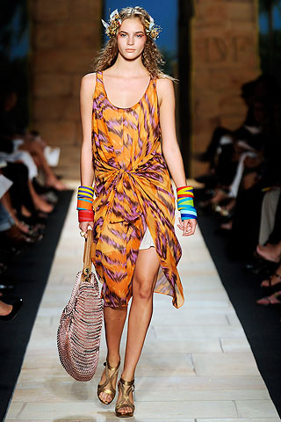Runway to ‘real’way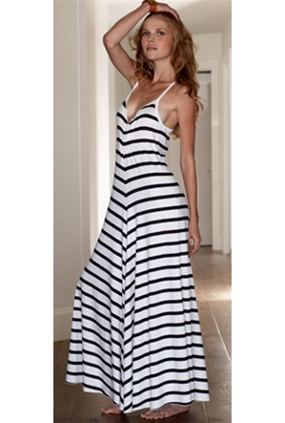
If you are headed to the shore-it’s time to go boho-chic once again. The Maxi-dress is here to stay! And while many a fashionista rocked the maxi in the city- I much prefer to see this long dress at the beach~ where it looks more at home and you’re not tripping over it to hail a taxi! . Look for ethnic themed pieces in interesting patterns and colors. Top it off with some beaded gypsy earrings and bangles or a simple cuff to bring your look from day to night and sunset cocktails! Also, stack some bracelets to top off your hippie-chic look. Read more about jewelry trends later in this issue with Jewelry trend Expert Jennifer Gandia. And don’t forget, you can also go nautical with striped shirts and dresses-another fave of the season.

Hot in the City! 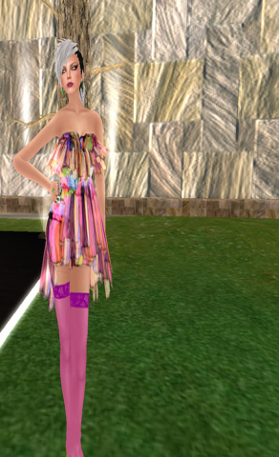
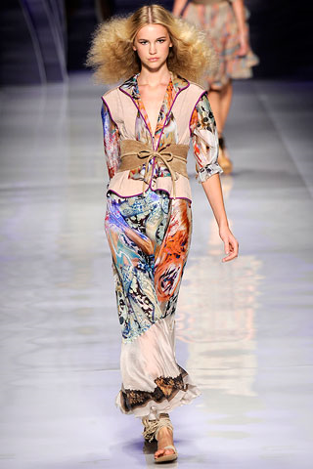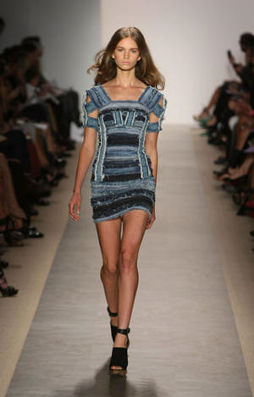 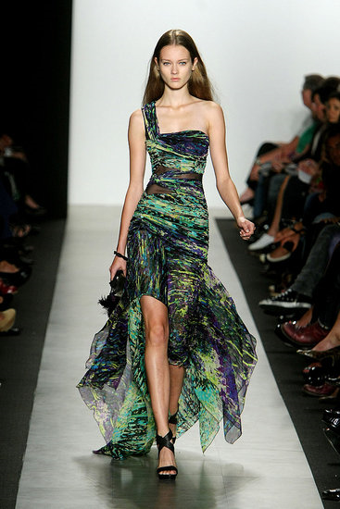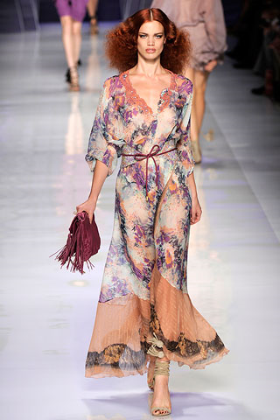Print it! That’s right-prints are making a statement this season, on glamorous dresses and sexy tops. Pair them with eclectic accessories items and you’ll have a downtown look all your own. Take a step in sexy platforms and strut your style in comfort. Prints work in the city and are also perfect for a beach-side look. Some of my favorite prints this season were from Etro and Max Azria. (pictured above).
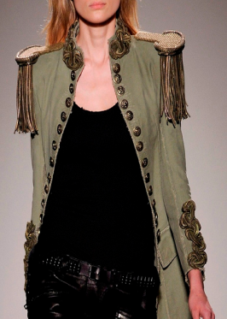 MILITARY Runway…to Real Way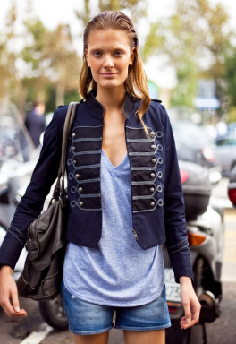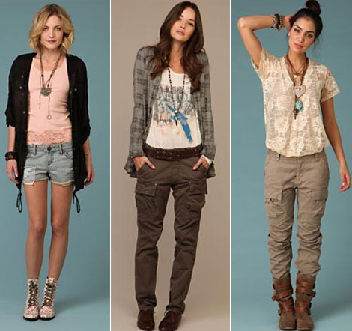Rock those Cargo pants! You can also rock the military look on the city streets-where you will be combat ready in cargo pants, vests, dresses and tops in utilitarian style. To soften this look , pair a vest or shirt with a soft dress or slim printed shorts.
Closing Style Notes for the Summer
Remember, no matter what your budget or body type-you Can rock these trends this summer. Look for lower-priced items at places like Free People, JCrew and knock-off brands like Aqua at Bloomingdale’s. And, if you want to go even lower, check out Forever 21, Zara and H&M for the latest trends without the high price tag. Also, don’t rock any one trend from head to toe-that’s even worse than being a label whore! Try and find what works for you –and be honest with yourself. If that super long maxi dress makes you look even shorter-then go for a short dress or skirt. If you get lost in that busy print, lose it and go with neutrals. But just remember to sit back, relax and have a cocktail-it is summer after all!

Bejeweled, Bedazzled & Best Dressed!
No matter how well-informed we are about the current fashion trends, there’s always more to know about how to make our look really pop! And it doesn’t hurt to know how not to commit a fashion faux pas by ruining an otherwise great ensemble with the wrong accessories. We recently spoke with jewelry trend expert; Jennifer Gandia of Greenwich Jewelers in Lower Manhattan.
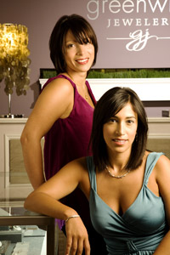 Jennifer Gandia (pictured left with her sister Christina Gandia Gambale ) is the daughter of a Jeweler, but her real passion was for fashion. She was reading Vogue Magazine at 13 years-old, went to FIT in New York City and worked in fashion PR for fashion icons Alexander McQueen, Badgley Mishka and well-known brands like Diesel and BCBG. She credits Francois Nars as being one of her greatest mentors-and she served as PR manager for Nars Cosmetics for many years.
After the events of 9/11, she began to reflect on her life and career and thought; “ while Public Relations is fun, it’s not very fulfilling”…and decided to take some time off to help her parents with their store, which was seriously affected by the attack. After helping her parents re-build she took another break and jetted off to Barcelona, Spain. While living in Barcelona for nearly a year, she was awed by the architectural and beauty and splendor of the city, but-oddly enough- often gravitated towards Jewelry store windows. After some serious soul searching she returned to New York, and decided that jewelry was her true calling and says “It’s funny how sometimes you have to go far away to realize that what you’re searching for is right under your nose.”
Jennifer Gandia Q&A with Style File:
What trends are we seeing For Summer 2010? 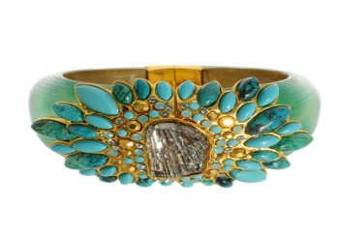(Bracelet by Alexis Bittar)
Summer 2010 jewelry is all about color. Turquoise is always a favorite, but bright greens such as the hues of peridot and chrysoprase are really popular this season. The stand-out trend is definitely stacking bracelets - mix and match a bunch of them to create a signature look that expresses your personal style.
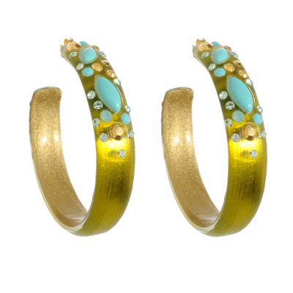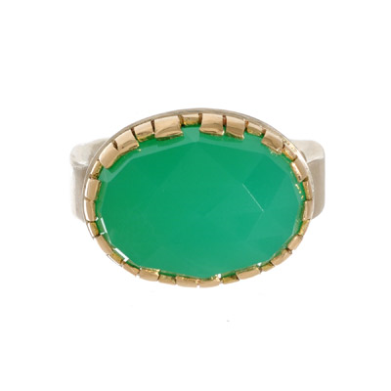
(Earrings by:Alexis Bittar, Ring:Jamie Joseph)

SF: With the recession still on-what advice can you give to those who want to invest in one piece of jewelry This Year. ?
Jg: I think there are two answers to this question. If you are the kind of person who wants a must-have item I would have to say a statement necklace. With the right one you can go out in NYC with a white t-shirt, black jeans and a killer necklace and you are DONE. You can take that same necklace and wear it over a black sheath dress & voila! – you are officially the best dressed woman in the room, and that can be a board room, dining room, where ever. That is the power of good accessories.

SF:How do you go about finding new Jewelry design talent?
JG: I go to trade shows, read magazines, blogs, internet , I look at women on the street. I am not above asking someone where the fabulous piece she is wearing comes from. Our store caters to all kinds of women so I strive to have designers that have very different points of view and price points. My father never wanted to turn someone away, and that is not to say he didn’t want to lose a sale, he wanted everyone who walked through the doors at Greenwich Jewelers to be able to leave with something special. He felt it was an honor to serve the people who came through his doors. I absolutely feel the same way and I’m always looking for great design and quality at all price points. It must look and feel special whether its $50 or $5000.
SF: What is the biggest mistake women make when wearing jewelry?
JG: I think the biggest mistake you can make is not taking chances. Jewelry is meant to delight you! It should be a talisman that when worm makes you feel MORE – your beauty and feminine power should be enhanced! If you are wearing the same styles and pieces over and over for many years you must shake it up a bit. Find something that speaks to you whether it be from a street vendor, antique shop or a great jewelry store and treat yourself. Trust me, it’s money well spent!

Thanks Jen! For more information go to: GreenwichJewelers.com

